Ideation Phase
Define the Problem Statements

Date | 31 October 2025
Team ID | NM2025TMID06949
Project Name | Laptop Request Catalog Item
Maximum Marks | 2 Marks

Problem Statement Template
Employees in the organization need a quick and efficient way to request laptops for work. The current process is manual and prone to delays, with no dynamic form behavior to guide users or ensure accurate data collection. To address this, a Service Catalog item needs to be created, allowing users to easily request a laptop, with dynamic fields, clear instructions, and additional functionality like resetting the form if needed. The solution should also ensure all changes are tracked for governance and deployment.
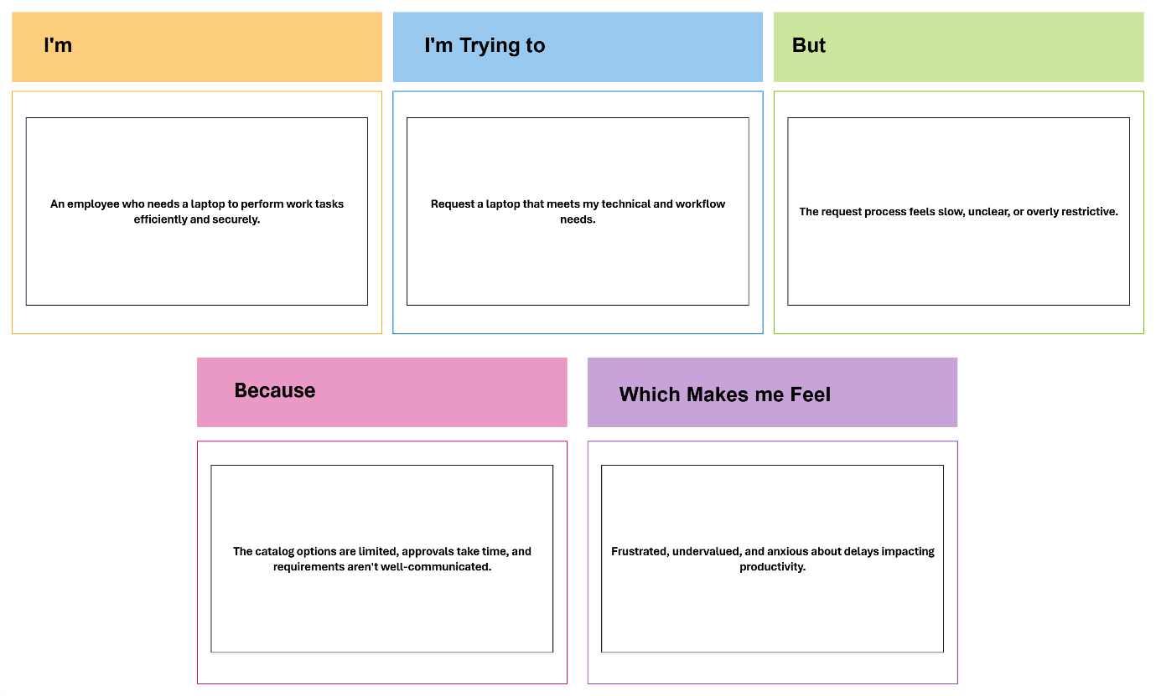

PROBLEM STATEMENTS:

